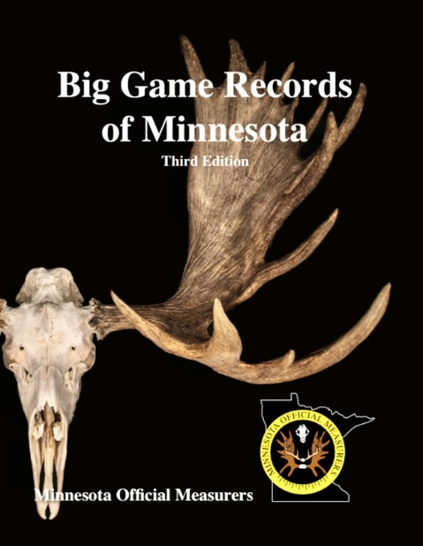

Big Game Record of Minnesota, Third Edition is filled with all trophies entered prior to July 1, 2023. New to the Big Game Records of Minnesota Third Edition, is the inclusion of the trophies Gross Score when it was available. Previous editions of the record book only included the Net/Final Score. Besides the addition of the Gross Score the third edition has over 1800 new entries, new stories & photo’s, updated trophies of the year, updated ranks for all categories of Big Game Animals of Minnesota, including shed records.

We are sending out postcards to all new entries in the third edition book. The front of the postcard has the image of the books cover, our logo and name, and website. The back of the card has the following description:

The Minnesota Official Measurers (MOM) is excited to announce the recent release of their Third Edition of the Big game Records of Minnesota.
The book contains over 30 years of Minnesota Big Game records. With over 1800 entries since the 2nd edition was printed. This high quality 8.5” x 11” hardcover book is over 300 pages containing over 15,000 trophy entries. It also has many photos along with several stories of successful hunts.
The book contains big game records organized by county for easier look-up and research. It also contains more photos and a complete section for shed antlers.
Order yours today while supplies last…
Only $35.00 from your local measurer. Online orders are $44.00 which includes shipping handling. All of this can be found at mnmom.com
Questions? Email us at submissions@mnmom.com

